Middle East Unit Plan Outline:

Day 1: Physical Geography
Day 2: Natural Resources
Day 3: People of the Middle East
Day 4: Women roles in the Middle East
Day 5: Unrest in the Middle East
Day 6: Current Events
Day 7: Work Day
Day 8: Work Day/ Presentations
Day 9: Presentations/Test Review
Day 10: Test

Lesson Plan: Day #1—Overview of the Physical Geography of the Middle East
Materials Needed: SmartBoard/ActiveBoard, Powerpoint software, 2 Sets of blank maps of the Middle East region, Powerpoint for lecture, colored pencils or crayons
Standards:
9–12.5.2 Interpret the relationships between physical environments and society (e.g., humans modify environment, environment modifies society, and use, distribution, and importance of resources)

9–12.1.1 Interpret and evaluate a variety of visual representations (e.g. charts, graphs, time lines, graphic organizers, maps, flow charts) of data
Objectives:
Students will:
- Understand the climate and environment of the Middle East
- Interpret and analyze maps for the location of the countries in relation to each other and the world
- Interpret and analyze maps to understand the landscape and major land features (e.g. rivers, mountains, deserts)

Lesson Activities:
- Anticipatory Set: Give each student a blank map of the Middle East and have them fill in the countries they know and write down ONE fact they know about the Middle East

- Quick whip around of student’s facts

- Go over correct map on board by having students come up to the Smartboard and drag country names to the correct location on the map. Students will fill in the correct countries on their personal maps as well. Quick description of some important facts from countries.

- PowerPoint lecture on Landscapes and Climate of the Middle East.

- Turn and Talk (closest neighbor)
Prompt: Do you think the climate and landscapes of this region impact the people of this region in their daily lives such as employment, diets, and general activity? How?
- Hand out blank map of the Middle East. Students can work on this the remaining class period if time allows or it will be assigned as homework.

Assessment: Students will complete a map worksheet, so students can refer to it for the rest of the unit. It will be helpful when comparing physical geography and human geography of the region. Students must label: countries, rivers, mountain ranges, seas, deserts, and oceans. They can use textbooks or other resources. Important cities will be added in a later lesson.

Reflection: For students with visual impairments or other learning disabilities, I will give copies of the PowerPoint lecture to them. Most students will take their own notes from the lecture.

Teacher Notes and Research for Lesson #1:
Introduction
Defining the region of the Middle East is a task in itself. On Google Maps each map adds or eliminates countries from the region. In order to understand the whole Middle East we must come to grips with how we define the Middle East. In this unit we will go over the Middle East region which includes Egypt, but excludes the rest of North Africa. Regions are difficult to define and all of them change over time. We will go over the region both its physical and human geography because they both impact each other.
The Land
The land of the Middle East is as you guessed it mostly desert. While it is often seen as a desert area, the region also has mountain ranges, major rivers, and is home to the fertile cresent. The mountain ranges are the Hejaz, Asir, Taurus, and Zagros mountains. The rainfall is much different in mountain areas. Water is life in this area. The rivers flood, which creates fertile crop soil. Yearly flooding is what keeps agriculture going in this area. The major rivers in the region are the Nile River, and the Tigris and Euphrates Rivers. The Nile River is the longest river in the world. Most of the population in the area live by water sources. The region is surrounded by seas. The Black Sea, Caspian Sea, Arabian Sea, Red Sea, and the Mediterranean Sea.
Climate
This region has multiple climates. Deserts cover 50 percent of the region. It is hot and dry in these areas. The Desert Climate is the major climate of the area. As you can see on this map the climate is mostly desert, but it also covers other climates. It has hot, arid climates to more temperate climates, where agriculture is better. As you can see this with most of the region being desert, Climate change and water availability in the Middle East are important in understanding human adaptive capacities. The climate majorly affects where people live, how they make a living, and how to supply food. The people of this region have had to adapt and now most of them live by water sources.

Name:__________________________________

Directions for Map:
Label each country that is white
Label each sea
Shade in brown where the mountain ranges are located
In Blue draw and label major rivers
Shade in yellow the land that is desert

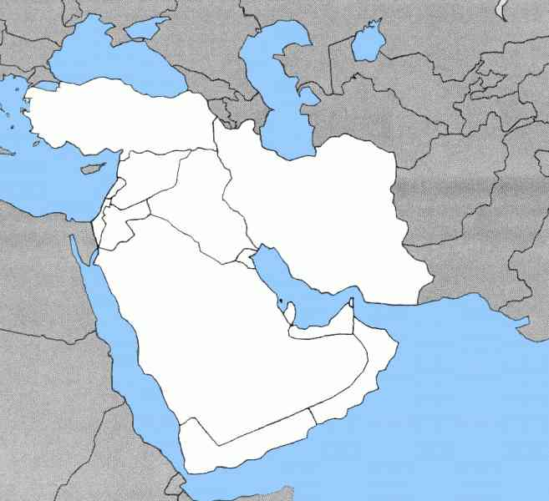

Lesson #2 Natural Resources of the Middle East
Materials Needed: picture of Dubai, Powerpoint, Computer/Projector, copy of article for each student, photos of Dubai and US gas lines
Standards:
9–12.5.1 Analyze the Earth’s human systems (e.g., population, culture, settlement, economic interdependence

9–12.5.2 Interpret the relationships between physical environments and society (e.g., humans modify environment, environment modifies society, and use, distribution, and importance of resources)

9–12.1.1 Interpret and evaluate a variety of visual representations (e.g. charts, graphs, time lines, graphic organizers, maps, flow charts) of data

9–12.1.3 Draw conclusions based on the research processes (e.g., collect, organize, evaluate, and synthesize information)
Objectives:
Students will:
  - Understand the connection between the geography of the Middle East and the United States.
  - Understand the importance of natural resources to the economy and political structure of the Middle East
  - Analyze readings to draw conclusions about oil’s impact
  - Apply background knowledge of oil in North Dakota to the current impact of natural resources of the Middle East
Activities:
- Bell ringer: What is the major natural resource of the Middle East? What is a scarce natural resource of the Middle East?
- Have students analyze photo of Dubai, U.A.E.
  - Questions: What do you notice about this photo? Do any of you know where this is located? Why do you think this is beautiful and modern?
- PowerPoint on oil in the Middle East and Water in the Middle East
- Video on oil in the Middle Easthttps://www.youtube.com/watch?v=PoQpwNV2iWQ
- Display photo of United States gas lines on December 23, 1973.
  - Question: Does the geography of the Middle East impact North Dakota and the United States?
- Hand out 2 different articles to students based on their Lexile reading level.
  - https://newsela.com/articles/oilprice-effects/id/6478/ (lexile 930)
  - https://www.nytimes.com/2017/02/13/business/energy-environment/opec-oil-energy-cuts.html (lexile 1300)
- Give Text annotation directions.
- Pair student with different articles together, students begin reading separate articles. When finished, students discuss articles with partners.
- Handout homework assignment and if time allows, whole class discussion. Assessment:
Students will write a paragraph (5-8 sentences) answering the following question: How does the OPEC deal of 2016 impact the Middle East region AND the United States?
Reflection: I taught this lesson for my full teach, and I thought it went pretty well. Next time I need to slow down talking and maybe go into depth more. I also need to add more pictures to the PowerPoint to show and not just tell.

Lesson Plan Day #3- The People of the Middle East

Materials Needed: Ipads/Computers for each student, blank maps, PowerPoint, SmartBoard, Map Exploration Worksheet

Standards:
9–12.5.1 Analyze the Earth’s human systems (e.g., population, culture, settlement, economic interdependence

9–12.5.2 Interpret the relationships between physical environments and society (e.g., humans modify environment, environment modifies society, and use, distribution, and importance of resources)

Objectives:
Students will
- Draw connections between the physical geography and population distribution
- Explain the ethnicities of the Middle East
- Apply their knowledge of the physical geography to the human geography
- Analyze maps to draw conclusions about the Middle East that are not specifically pointed out

Lesson Activities:

- Blank map quiz for students to fill out on the country locations (formative assessment)
- Lecture on population of the Middle East (analyze maps for population distribution)
- Discussion prompt: Why is the population distribution of the Middle East (according to the map) like this? What is the main factor?
- Map Exploration:
  - Students go to www.worldmapper.com
  - Click on map categories on the top of the page
  - Browse the categories and click on different categories and maps to find maps that would make the Middle East larger or smaller. (show example on board)
  - Take 4 minutes (countdown on board) to just browse the website and become familiar with what information you can get from the website.
  - Write down TEN inferences you made from browsing maps on the sheet provided.
  - Students who are done early will have a question on the board to work on. Question: Analyze map #14 Refugee Origin. With any knowledge of current events, why do you believe the Middle East has the largest percentage of refugees leaving the region? What are a few reasons people would leave their homeland?
- If time allows: Get into groups of 4 (drawn randomly from sticks) to share discoveries and compare.
Assessment: Students will analyze maps to draw conclusions about the region of the Middle East. Each student will be graded based on this checklist:
Completion of TEN inferences _____/5
Inferences are concise and accurate ______/5
Time Management and On Task Behavior ____/5
Total ______/15
Reflection: The map exploration may be confusing for lower performing students. I will need to walk around and assist students as well as provide clear and concise student directions.

Directions for Map Exploration Activity:

1.On your IPad/laptop, go to www.worldmapper.com.

2. One the website, click on Map Categories on the top of the page. On the left side of the page are the categories. Click on a few categories that you think the Middle East would do well in (e.g. the map on oil exportation). Browse through the maps until you find one that portrays the Middle East as large or small (e.g. the map on oil exploration).

3. Draw inferences from maps you find interesting. Example of an inference is: According to map #19 Tourist Destination, Europe is one of the most popular tourist destinations in the world. Make 10 inferences like the example for the Middle East. (According to map # and title of map, the Middle East has a high level of fill in the blank.

4. On a blank piece of notebook paper, write down your TEN inferences.

5. Due by: Tomorrow’s class period

Teacher Notes and Research for Lesson #3:
Introduction
“We often perceive the Middle East in negative and particularistic contexts, such as terrorism, instability, violence, Islamic fundamentalism, anti-Americanism, oppression of women, or oil wealth.” People, especially Americans, tend to oversimplify the geography of the Middle East. We stereotype all Muslims as terrorists and all Arabs as rich oil people. We need to look into the human geography of the area to really understand the daily life and society of the Middle East.
Ethnicity
The Middle East is the crossroads between Africa, Europe, and Asia. Since it is the crossroads, many different ethnicities come together. The Middle East has been said to be a “rich mosaic.” The ethnicities in the region include the Arabs, which is the vast majority of the population. 60% of the population of the Middle East claims to be Arab and speaks Arabic. The Israeli’s are another ethnic group in the area. They are the Jewish people who were given Israel as a homeland in 1948. The Israeli’s are in conflict with the Palestinian’s over the land of Israel. This is a major cause of violence and tension in the region. We will go into that in a few lessons in the unit.
The region also is home to Turks, Armenians, Kurds, among many others. Iranians and Afghanis are both non-Arab ethnicities in the region. Armenians and Kurds have been struggling to form their own countries, but have yet to make the change. Kurds are known as one of the ancient nations. They currently do not have their own nation, but they are ethnic group spread over Iran, Iraq, Syria, and Turkey. They are known as one of the largest indigenous groups in the world without a nation-state. The right of self-determination is still being tried by the Kurds, but has been defeated multiple times.
Population Density:
The population distribution of the Middle East is something to take note of. Most of the population lives near a water source. Water is life in the Middle East. In Egypt the majority of the population lives along the Nile River, leaving a large portion of the land scarily populated. In Iraq, most people live along the Tigris and Euphrates Rivers. Turkey, Egypt, and Iran have the highest populations of the region.

Lesson Plan Day #4- Women in the Middle East
Materials Needed: DVD Player or laptop, projector, Whiteboard/Smartboard
Standards:
9–12.5.1 Analyze the Earth’s human systems (e.g., population, culture, settlement, economic interdependence
W.2 Write informative/explanatory texts* to examine and convey complex ideas, concepts, and information clearly and accurately through the effective selection, organization, and analysis of content.
Objectives:
- Understand the importance of Islam in the Middle East
- Analyze politics through a religious view
- Understand the importance of the Middle East in world religions
- Evaluate the roles Islam and society play into women’s roles in the Middle East
Lesson Activities:
1)Direct instruction on the background knowledge of religion from previous day and how the religion impacts women in society
2) Show small portions of the film “Veil of Dreams” with class discussion about similarities and differences between American women and Middle Eastern Women
3)Assign half-page response as homework or allow them to start in the final minutes of class
Assessment:
Half-page video answering the question: How do women’s lives in the Middle East compare to women’s lives in the United States? At the end of the video they share how women’s roles are modernizing, do you see this trend continue?
Reflection:

Teacher Notes and Research for Lesson #4:
Women
Women in the Middle East have different experiences based on locations and situations. The region is very patriarchal which means, “manifestation and institutionalization of male dominance over women and children in the family and the extension of male dominance over women in society in general.” This in itself sets a different tone on how women are seen and treated in the Middle East. The United States and Americans believe that Islam is the only oppressor of women in the Middle East. While women are veiled, dress modestly, and hold a quiet demeanor. Not all women in the Middle East are oppressed. All of them definitely live different lives than we do here, but it is not uniform for the region. Iran has religious rule, but Turkey has a secular rule. The governments along with religion oppress women. So much goes into the gender inequality in the Middle East, but religion is not the sole cause of oppression. “Women from the nations of the Middle East are just as much a product of their culture as of religion, even if the distinction is difficult to make.” Culture, government, and religion all affect women, but oppression cannot solely be blamed on Islam. “The status of women in Muslim societies is neither uniform, nor unchanging, nor unique.” Modernization has changed how women are being treated. Women have stood up for their beliefs and have demanded change. It will continue to change throughout time, but women’s roles in society is important to note when studying this region.

Lesson Plan Day #5- Unrest of the Middle East
Materials Needed: photos of destruction and conflict, SmartBoard, Computer, one copy of each propaganda poster for each student, lecture handout for each student
Standards:
9–12.1.3 Draw conclusions based on the research processes (e.g., collect, organize, evaluate, and synthesize information)
9–12.1.4 Use media (e.g., oral, written, websites, computer simulations, multimedia resources) to access, record, analyze, and communicate information relating to social studies

Objectives:
- Critically analyze examples of propaganda
- Applying good communication skills in large and small groups
- Display critical thinking about the cause of conflicts in the Middle East
Lesson Activities:
- Explanatory video on Shiite/Shia split of Islam. https://www.youtube.com/watch?v=5KLvjs7Yrtw
- Direct instruction on ISIS, the Israeli-Palestinian conflict, and Sunni-Shia conflicts throughout the Middle East
- Show photos of different conflicts in the Middle East (Israel-Palestine and ISIS particularly) and the destruction that they have caused. Students will answer prompt in groups of 3 randomly drawn partners: From what we have talked about earlier in this unit about society, culture, ethnicity, and religion, why do you think there is this much destruction in the Middle East?
- Propaganda Activity: Each student will receive a page of propaganda posters (also projected on Smartboard) on both the Israel and Palestine side of the conflict. 5 minutes for students to analyze posters and write down what they think about the posters.
- After those 5 minutes, I will present 2 questions: What do you think this poster is trying to show or tell? and Do you think this poster is biased, why or why not?
- Pair and Share on the answers students gave and then move to a whole class discussion on the topic
Assessment:
No summative assessment will be taken on this lesson because it is more about critically analyzing and professionally communicating thoughts and ideas through discussion. I will check with each student formatively for understanding during the discussion.

Reflection:

Teacher Notes and Research on Lesson #5
Introduction
The Middle East is often looked on as volatile and unstable. The American news is filled with violence and death from the Middle East. The current topic of conflict in the Middle East is ISIS. Terrorism is a hot topic stemming from that region. ISIS is not the only cause of tension in the area though. “In the Middle East though, it is important to not combine Islam and Islamic Violence. Not every Muslim is a terrorist and not every Islamic rule will turn violent. It is proven that,” the dominant view in the West assumes an affinity between Islamic values and the use of violence in the Muslim world, particularly violence of a political nature.” This is the first thing that must be held into account when looking at the conflict in the Middle East.
Examples of Conflict
ISIS, Syria, Israel, Palestine, oil are all topics everyone has heard of. A few examples of tension come from Shia and Sunni power controls. In Bahrain, the Shia are not in power and are marginalized. “The Shia- Sunni schism is a source of destabilization in other countries such as Iraq and Pakistan.” The area is full of oppression and violence against the other faction, “which ultimately damages the Muslim world.” Syria is another example of the Shia-Sunni conflict. It is a conflict that continues on and affects most of the region. Power changes hands and both sides are equally oppressed at different times. It is a major source of tension in the region.
Another source of conflict is the Israeli Palestinian Conflict. This conflict is a fight over the land of Israel. It was given to the Israelis as a Jewish homeland, but the Palestinians believe they were there first. Both sides are raised to hate the other, so the violence will continue on. Israel is a very unstable country. The conflict is sometimes shadowed by the new ISIS conflict, but this conflict has continued for quite some time and will continue on. Both sides will continue to lose life. This is still a current issue in the region.
Religion:
The Middle East in the epicenter of world religion. Three of the world’s major religions originated in this region, Judaism, Christianity, and Islam. All of the religions share in tradition. They all had similar prophets, including Jesus for Christians and Muslims. Jerusalem, the capital of Israel, holds significant religious sites for all three religions. Although the region is the birthplace of three major religions, the majority of the population is Muslim. Israel is the only country in the region that is not Islamic, as it is the Jewish homeland. The Islamic faith impacts the people of the Middle East greatly. It affects not only the daily life and politics. Some countries such as Saudi Arabia are considered religious states. Being a religious state means that “they prioritize the full application of religious law in all political, social, and economic matters.” Not all countries in this region are religious states, but Islam, while not the only religion, plays a large part in the region. Having religious states can be controversial though, when other religions are present. The conflict between Israel and Palestine did not originate from a religious problem, but religion is part of the conflict. “The more diverse a country’s religious population, the more violent its domestic conflicts tend to be.” In the case of Israel and Palestine, the land of Israel is the birthplace of three religions. There is a religious diversity in the area and there is violence.
Much of the tension and fighting in the region comes from the split of Islam. The split occurred after the succession of Muhammad. Muhammad is believed by Muslims to be “the final prophet, delivering God’s last set of instructions to humankind.” When Muhammad died, his followers were unsure of his successor. The majority of people felt that the new leader should be picked from the community. That group is called the Sunni’s. The Shi’a are those who believed that the successor should be a related by blood to Muhammad

Lesson Plan Day #6: Current Events of the Middle East
Materials Needed: Computer/Ipad for each student, list of websites that articles can be found at
Standards:
9–12.5.1 Analyze the Earth’s human systems (e.g., population, culture, settlement, economic interdependence

9–12.1.3 Draw conclusions based on the research processes (e.g., collect, organize, evaluate, and synthesize information)
W.8 Gather relevant information from multiple authoritative print and digital sources, using advanced searches effectively; assess the strengths and limitations of each source in terms of the task, purpose, and audience; integrate information into the text selectively to maintain the flow of ideas, avoiding plagiarism and overreliance on any one source and following a standard format for citation.
Objectives:
Students will:
- Use the research process to find an appropriate news article
- Critically analyze the article for bias and main points
- Compare and contrast event to events in the United States
- Accurately relay research into writing
Lesson Activities:
- Review of propaganda and media bias from previous day

- Studetns will read both articles on similar topic from 2 different news sources. http://www.cnn.com/2017/02/27/middleeast/iraq-army-seizes-key-mosul-bridge/index.html
http://www.foxnews.com/world/2017/02/26/iraq-officials-recapture-new-neighborhood-in-mosul.html

- Create Venn Diagram comparing the two articles to analyze different sides of the story and biases the news may have.

- Hand out directions for Current Event Article Review and Presentation.

- Explain project and have students begin researching news articles online.
The Project: students will research and pick one news article on the Middle East. It can be a topic of their choosing, but it must be from the Middle East. I have the final discretion on articles. They will then create an article review. The article review will require students to summarize the article, understand the main point of the article, analyze bias in the article, and compare and contrast the events with events in the United States. The article must be one page in length, double spaced. To start their research they must create a brief concept map to get the main ideas of the article. Once they have a preliminary concept map, they can then begin writing the article review.

- Students will have all class period to research an article and write the article review.
- Students will also be responsible for sharing the summary and main point with the whole class the following day. This gives students the chance to hear different events occurring in the Middle East. They will be an “expert” in one event, but will hear many other events.

Assessment:
There will be no formal assessment during this lesson because students will display knowledge of media bias and current events in their article review and presentation.

The article review will be the summative assessment for this lesson because it will assess student’s ability to pick an appropriate news article and critically analyze it for inmportant information and bias. It was also display student’s ability to compare and contrast with their own lives as well as professionally display their thoughts through writing.
Reflection:

Lesson Plan Day #7 – Work Day for Article Review and Presentation
Materials Needed: Each student will need a laptop or IPad
Standards:
9–12.1.3 Draw conclusions based on the research processes (e.g., collect, organize, evaluate, and synthesize information)

9–12.1.4 Use media (e.g., oral, written, websites, computer simulations, multimedia resources) to access, record, analyze, and communicate information relating to social studies
W.2 Write informative/explanatory texts* to examine and convey complex ideas, concepts, and information clearly and accurately through the effective selection, organization, and analysis of content.
W.8 Gather relevant information from multiple authoritative print and digital sources, using advanced searches effectively; assess the strengths and limitations of each source in terms of the task, purpose, and audience; integrate information into the text selectively to maintain the flow of ideas, avoiding plagiarism and overreliance on any one source and
Objectives:
Students will
- Research news article on current event in the Middle East
- Analyze article for bias and important facts
- Create article review
- Create presentation
Learning Activities:
- Students will have all class period to find article, read and analyze article, and create an article review and presentation.
Assessment: The assessment of this will be on day 8 of the unit plan when students present and turn in their article review.
Reflection: This day may go need more time, so it may be moved into two days, but I believe if students are on task it can be completed in one day.

Article Review Rubric (to be handed out to each student)

 | 4 | 3 | 2 | 1 | Your Score
Reference | - APA style is Perfect  - | Minor edits needed. | Major edits needed. | No article reference.
Review of  Article | Major points selected and discussed. | Same as 4, but selects couple minor issues or no supporting example explained | Does not focus on major issues | Missed the jest of the article.
Writing | Clear articulate writing used. No grammatical errors. | Minor edits needed. A few grammatical errors. | Major edits needed. 5+ grammatical errors and unsatisfactory writing style. | Paper is filled with grammatical errors, poor sentence structure, and unsatisfactory writing style.
Organization of writing | Well organized thinking that reviews the article, discusses the major points in an order that makes sense. | Minor jumping around on points. Could be better with few minor moves. | Major jumping around on points made in review. Major organizational edits needed to articulate clearly. | No organizational thought demonstrated in writing of review or major points discussed in the article.
Your Thoughts | Articulates your thoughts on the article in clear manner. Discusses what you learned from reading the article. | Articulates your thoughts on the article well, but only briefly mentions what you learned from article. | Brief mention of thoughts, but did not elaborate. | Does not write any personal thoughts on the article.

Rubric modified from oekate.murraystate.edu/media/professors/files/.../Rubric_JournalArticleReview.doc

Article Review Directions and Requirements
Directions for Article Review:
- Find intriguing news article on the Middle East using CNN, FOXNEWS, Newsela, or another news outlet. The article can be on any appropriate topic and it must be published within the last 3 months.
- Bring article to teacher for approval for content and reading level.
- Read article and text annotate.
- The article must contain:
  - Time and place of the article
  - The major point of the article
  - 4 points of evidence that supports the main point
  - If any, what bias can you read
  - Relate current event to something we covered in the unit (climate, religion, women, oil, etc.)
  - Your thoughts on the event
Article Requirements:
1 Page, Double-Spaced, Typed, 12 pt. font, Times New Roman
APA reference of article
Attach your annotated copy of article with article review
Will be graded based on rubric

Presentation Directions & Requirements
Directions for Presentation:
- This is an informal presentation of your current event
- Summarize article by sharing
  - Place
  - Time
  - Where you found the article
  - What happened
  - Any causes of the event
  - Any effects or future effects of the event

Presentation Requirements:
Presentation must be 5-7 minutes
Note cards are allowed
Good communication skills (enunciation, eye contact)

Day 8: Presentations/Continued Work Day
Materials Needed: Laptops/IPads may be needed if part of day is a work day
Standards:
9–12.1.3 Draw conclusions based on the research processes (e.g., collect, organize, evaluate, and synthesize information)

9–12.1.4 Use media (e.g., oral, written, websites, computer simulations, multimedia resources) to access, record, analyze, and communicate information relating to social studies
W.2 Write informative/explanatory texts* to examine and convey complex ideas, concepts, and information clearly and accurately through the effective selection, organization, and analysis of content.
W.8 Gather relevant information from multiple authoritative print and digital sources, using advanced searches effectively; assess the strengths and limitations of each source in terms of the task, purpose, and audience; integrate information into the text selectively to maintain the flow of ideas, avoiding plagiarism and overreliance on any one source and
Objectives:
Students will:
- Create article review
- Create presentation
- Present article findings in front of class
- Communicate using academic language and strong communication skills
Lesson Activities:
- If additional worktime is needed, students can finish up for 15-20 minutes.
- Students will present article findings of current event to class, each presentation taking about 3-5 minutes.
- If all presentations are finished, class discussion on reoccurring themes of articles.
Assessment: Students will be graded on the article review and presentations separately. Article Review Rubric on previous page.
Reflection:

Lesson Plan Day #9: Presentations/Test Review
Materials Needed: Test review sheets
Standards:
9–12.5.1 Analyze the Earth’s human systems (e.g., population, culture, settlement, economic interdependence

9–12.5.2 Interpret the relationships between physical environments and society (e.g., humans modify environment, environment modifies society, and use, distribution, and importance of resources)

9–12.1.1 Interpret and evaluate a variety of visual representations (e.g. charts, graphs, time lines, graphic organizers, maps, flow charts) of data

9–12.1.3 Draw conclusions based on the research processes (e.g., collect, organize, evaluate, and synthesize information)

9–12.1.4 Use media (e.g., oral, written, websites, computer simulations, multimedia resources) to access, record, analyze, and communicate information relating to social studies
W.2 Write informative/explanatory texts* to examine and convey complex ideas, concepts, and information clearly and accurately through the effective selection, organization, and analysis of content.
W.8 Gather relevant information from multiple authoritative print and digital sources, using advanced searches effectively; assess the strengths and limitations of each source in terms of the task, purpose, and audience; integrate information into the text selectively to maintain the flow of ideas, avoiding plagiarism and overreliance on any one source and
Objectives:
Students will:
- Understand the basic concepts of the unit
- Critically analyze how the human geography is impacted by the physical geography
- Evaluate the differences between the United States and the Middle East in relation to women’s roles
Lesson Activities:
- If needed, there can be time for final presentations and debrief of all presentations
- Review for test by going over major themes of the unit
Assessment: Unit plan final assessment will be day #10 test.
Reflection:

Lesson Plan Day #10: Test
Today will be the final assessment of the unit. It will be a multiple choice, map, essay, and short answer test.
Students will have 50 minutes to complete the test.

Propaganda Posters:
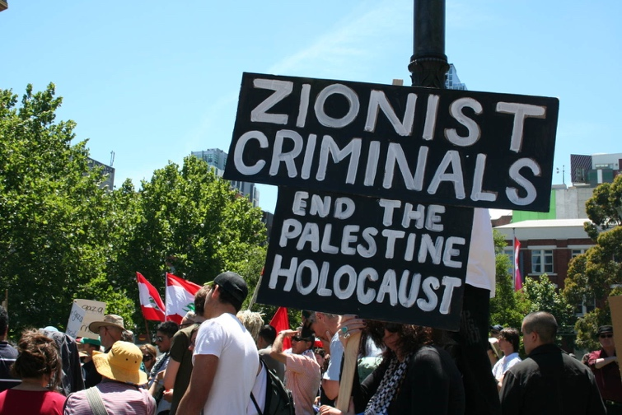

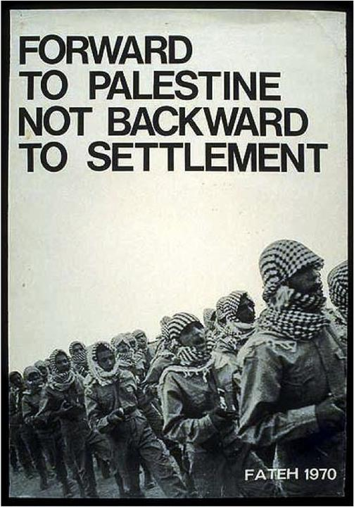
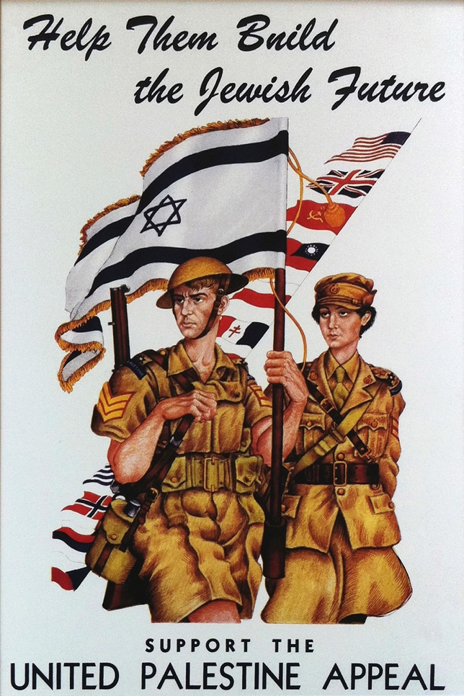

Geography of the Middle East Unit Exam
Name:_________________________________

Multiple Choice Questions: Please circle your choice. There is only one correct answer.

What is the primary landscape of the middle East?
- Mountains
- Rainforest
- Desert
- Plains

What is the land between the Tigris and Euphrates Rivers called?
- Fertile Crescent
- Great Plains
- Quarter Moon
- Tigris Valley

What is the most abundant natural resource in the Middle East?
- Water
- Oil
- Salt
- Silver
What is the least abundant resource?
- Water
- Oil
- Salt
- Silver

What are the 3 major world relgions that originated in the Middle East?
- Christianity, Islam, Buddhism
- Christianity, Hinduism, Judaism
- Christianity, Islam, Judaism
- Christianity, Taoism, Judaism.

What is the ethnicity majority?
- Kurds
- Iranian
- Palestinians
- Arab

What is the primary religion of the Middle East?
- Christian
- Islam
- Judaism
- Taoism

What country produces the most oil in the Middle East?
- Saudi Arabia
- Iraq
- Iran
- Oman

Short Answer Questions: Answers do not need to be full sentences.

Name 3 conflicts that are going on in the Middle East and describe them.

List 3 of the current events gone over during class presentations. Briefly describe each one.

Essay Questions: Please write 5-7 full sentences to display your knowledge of the content.

How does oil impact the region of the Middle East?

How does the environment impact the people of the Middle East?

Map Test: Label each country highlighted in white with the correct name. The list of countries needed for map is on the SmartBoard in the front of the room.

