Cultural Diversity Final Paper
Maci Abrahamson
University of Mary

Cultural diversity is something that will forever be present. The United States is called the melting pot for one reason. The country and world is full of diverse people and it is crucial that people understand cultures and know how to interact with all people. All cultures bring differences and similarities into the world. The United States is great because of what each culture brings to it. This class has taught me about many cultures. With my previous experience and new found knowledge, I can better interact with the world around me. Knowledge is the first stepping stone in ending stereotyping and prejudice. In this paper I intend to reexamine my autobiographical paper written at the beginning of the semester in light of the knowledge obtained through texts and will conclude with answers to 5 questions that are asked in light of my future career as an educator.
Diversity is something that should be celebrated and welcomed into society. In reality, it is not celebrated, but often used to discriminate against. Each culture has diversity in itself. “It is extremely important to note that not all people from one cultural group can be grouped together and assumed to be alike” (Spradlin, 2012, p. 6). Every culture has similarities among its people, but each person is still created uniquely. People should not stereotype based on culture. People should not stereotype at all. In my life, I have witnessed discrimination of diverse people, but I have witnessed acceptance of diversity. It is something that should be welcomed because it brings different ideas and ways of thinking. Diversity makes the world great, yet the United States often wants to assimilate individuals into the American culture. We want everyone to act American and get rid of their own culture. “And, even though some minorities and their descendants may desire to become acculturated and may make every effort to adopt be unattainable for most minorities because assimilation requires that they be fully accepted as equals,” (p. 19). Even if the cultural group in the United States wants to be acculturated into the country, that would mean as United States citizens, we would have to accept them as equal. That is something that I believe America struggles with. We want minorities to act more American, yet we still do not see them as equals. They will always be minorities because they will never be seen as equal, no matter what they do to acculturate themselves. This is a problem that needs to be addressed in the United States. Diversity makes the world great and should be celebrated. No culture should have to be pushed into a different culture. Assimilation should not be required.
When I look back at the past twenty one years of my life in my previous autobiographical piece, it has not been marked with diverse people or experiences. I grew up on a farm about fifteen miles from the nearest town. The nearest town only had a population of about 150 people. My mom worked at home, so I never attended daycare as a child. My first major experience with new people was kindergarten. My classroom was typical of a small town school in North Dakota. There was only one Native American student and one male teacher in the whole school.
After reading the text Diversity Matters, I made a small connection between small, rural schools and schools mostly attended by minority groups. “Due to family income limitations, enrichment programs, college preparation courses, and afterschool activities may be inaccessible to poor and working-class students” (Spradlin, 2012, p. 55). Rural schools have less to offer students than larger school districts do. Smaller schools cannot offer as many enrichment programs or many college preparation courses. Afterschool activities can be difficult because of the distance needed to drive to the activity or parents who cannot afford and have the time. Although I would say rural schools offer more than many low income schools, there is a connection. Inner city schools and schools in low socioeconomic schools offer students less which then greatly impacts students learning and success. All schools should be equal and offer the same education to all students, but that does not happen. I attended a small school, so many of our students came from low socioeconomic families and our school could not offer a lot of options for students. I would in no way compare my education to the education of an inner city school or minority schools, but there is a connection between school quality.
In terms of equality or just in general, each minority group has a different experience. Native Americans are the minority group I am most familiar with as I have lived in North Dakota my whole life. The knowledge I learned in this class reinforced my previous knowledge and also taught me new things about the culture. Everything You Wanted to Know About Indians went into detail on some aspects of the Native American culture that are often not known.
Fifth grade was the first year I could play basketball through the school. We played nearby towns. At this point in my life, I had never been southwest of my hometown. My first game of the year taught me that I lived about twenty miles from the Fort Berthold Indian Reservation. As Anton Treuer wrote, “I grew up in a borderland,” (2012, p. 1). I grew up on the borderland of the Fort Berthold Indian Reservation. My district for basketball included four towns on the reservation and two towns off of the reservation. That was something that I learned when I was a fifth grader.
As a child I did not expect the towns to be any different from my own small and in many ways they were the same, but there was always a certain side of town that was different. I was always scared to drive through that part of town. Everyone I knew avoided that area. I observed the areas as we did drive through them, but I did not realize until Anton Treuer pointed it out to me, what I was observing. “The Indian car is the one that is falling apart—its bumper is held on with duct tape and bailing wire, and the tires are all brothers from different marriages.” (Treuer, 2012, p. 47). The reservation towns were filled with these cars. I did not know that it was an actual thing until I read this book. I observed this in the communities in my area. Every reservation I have been has those cars.
After high school, I had more experience with reservations. I moved a few miles off of the Turtle Mountain Indian Reservation. It was at this time I attended my first powwow. I have to admit that I was nervous to go. Powwows, “usually last anywhere from one to three days, and they are open to people of all tribes, genders, ages, and races,” (Treuer, 2012, 68). I was the minority at the event, but it was amazing to watch. It was something new that had never witnessed before. It gave me new understanding of the Native American culture.
Studying the Native American culture is helpful living in North Dakota and hoping to teach in North Dakota or Montana because of the Native American population. The class covered many other cultural groups though that I have less experience with. Looking back on my childhood up to my senior year of high school, the most diversity I faced in life was going to school near a reservation. I accepted the diversity and grew to welcome it and learn from it. That was my only experience with diversity until my senior class trip to Washington, D.C.
As a senior in high school, my Social Studies teacher took my class of ten to Washington, D.C. with the program called Close-up. Close-up is a program that brings high school juniors and seniors from across the country to Washington, D.C. and New York City to learn about the United States government and history. The session I attended had around five hundred students from across the United States. I experienced more diversity in one week with that program than I had ever experienced before. I was roommates with two girls from Michigan. It was interesting getting to know them and what their lives were like. They were definitely city people which was a small taste of diversity for me, coming from a small North Dakota town. It is one thing meeting people from around the country, but living with someone for a week really shows the diversity.
For one week, I was placed in a small group of students from across the country. Those were the people I traveled with to tour the monuments as well as learn about the history of each monument. Our guides connected the monument with current issues and we held discussions on each issue and monument. The groups were diverse in socioeconomics, ethnicity, culture, gender and geography. As we talked about social issues and government it was amazing to witness how diversity can add so much to discussions. Geography had a large impact on social issues which I did not expect. Students from different states saw issues so differently. Gun control viewpoints differed widely between students from Alaska and Massachusetts. Gun control varied mostly between state, but the issue of gay marriage differed from person to person. That topic had to deal more with backgrounds and cultures than geography. It was great to see how different topics showed different aspects of diversity.
Not only was I immersed in a diverse group of students similar in age to me, I was also immersed in a diverse area. Washington, D.C. is filled with diversity. I saw senators and representatives. I toured the White House. I saw the wealthy parts of Washington D.C. were important people such as the president reside. On the other end of the spectrum, I was asked for money from homeless people and begged to buy trinkets off the corners. This continued as the we traveled to New York City for the final days of the trip. We traveled to New York City with about two hundred of the same students.
In New York City, we toured China town, visited Times Square, and drove by 5th Avenue. I was amazed by how many Asian Americans there were in New York City as well as Washington, D.C. I believe the cause of this was the Immigration Act of 1990. “The Immigration Act of 1990 increased the number of Asians coming to the United States by raising the total quota and reorganizing the system of preferences to favor certain professional groups” (Spradlin, 2012, 102). There were multiple cultural groups. The city was a mix like I had never seen before. We drove by areas where I was amazed at how the people were living. “According to the U.S. Bureau of the Census, approximately 28 percent of Latino families live in poverty, compared to 9.2 percent of non-Latino families,” (p. 121). Latino families, Asian families, African American families were mixed in the city. I observed everyone living peacefully on my trip, but each culture group has it’s issues. “While many would like to believe that the problem of racism in the United States in solved, it is obvious when examining the current conditions of African Americans living in the United States that there is much work to do toward achieving social justice, cultural pluralism, and equity in schooling and job access” (p. 145). Although it looked peaceful at the time, racism is still very much alive in America.
It was a very eye opening experience for me. The whole point of the Close-up program is to teach students about the United States government and social issues in a diverse way that opens the eyes of students. At the time, I was just excited to be out of North Dakota and was nervous to meet new people from different states. Looking back now, I realize what an amazing opportunity it was. I was allowed to study government in a fun way with mock legislatures and debates, but do it all while being immersed in a large group of diverse students who all had different opinions. Everyone respected each others opinions and debated respectfully. At no time on the trip did I witness any discrimination or disrespect. It was truly an amazing opportunity. I am more thankful for that trip today than I was when I was actually on it.
I started out my life with little diversity. I was raised on a farm twenty miles away from the nearest town and did not witness much diversity until I was in later grade school. Growing up near the Fort Berthold Reservation brought some diversity during basketball season and school events, but that was all of the diversity I witness in North Dakota. In order to experience more diversity, I had to leave the state. My trip to Washington, D.C. and New York City was filled with diversity, from the students I traveled and stayed with to the area itself. Although both cities were very diverse, they did not expose me to all minority groups in a personal manner.
Groups that I have not interacted with is primarily the LGBTQ community. I learned multiple facts about community and the discrimination they are impacted by every day. LGBTQ members often do not feel safe at school and many do not feel accepted at home either. (See Appendix C). It is very sad that this minority group has to deal with this on a daily basis. Not every state has bullying laws to protect LGBTQ members. (See Appendix D). This may make it scary for students to come to school because they are not protected. I did not know that “in thirty states, LGBT citizens can be fired on the basis of their sexual orientation and/or gender identity without any legal recourse, and as many as 39 percent of LGBT workers continue to experience some sort of workplace discrimination or harassment” (Spradlin, 2012, 211). My research presentation was a very eye opening experience in respect to the LGBTQ community. Although Spradlin says, “gay and lesbian individuals are often describes as having an invisible history” (p. 208), I found a historical timeline of the LGBTQ community that shows the progress made, but there are very few major historical moments for the community. (See Appendix A).
In conclusion, diversity is in the world around us. Diversity can be found anywhere, from North Dakota to New York City. As a future teacher, hopefully to teach in small town North Dakota, I wonder what diversity I will be faced with. “At some point, every human being will experience either physical or mental disabilities or both” (Spradlin, 2012, 233). Students with disabilities will be the major minority group I will teach.
Native Americans will be the next minority group I will have in my classroom the most depending on where I teach. This class taught me more about the Native American culture than living near the reservations did. I learned about the history and that “nobody knows for sure” about the exact beginnings of Native American’s in North and South America (Treuer, 2012, 15). I have never been around the tribal langauges either. I never knew that “there may have been as many as five hundred distinct tribal languages in North America prior to sustained contact with Europeans” (p. 15). Native American languages have become less and less until now when most of the populations cannot speak the native language. “Native Americans have been forced to replace Native languages with English in order to survive in dominant-culture-controlled boarding schools, reservations, and institutional policies and practices” (Spradlin, 2012, 90). As mentioned earlier in this paper, Americans believe everyone should assimilate. Our ancestors have and continue to take away the native language and force English upon Native Americans until the native languages are gone.
To wrap up this paper, I will ask and answer five questions to better enhance my learning on cultural diversity in light of my hopeful field of education. My first question comes from the fact that it is highly likely I will educate many Native American children. How can I best help Native American students when I see a need? “It can be very frustrating for nonnative people to know how best to reach out to Indians or to help address the problems in Indian Country” (Treuer, 2012, 163). It will be difficult, but with education and communication, everyone can work together for the best of everyone. As a future educator, how can I change curriculum to better the learning of all students? Spradlin answers that question with, “to transform curricular, educator must place emphasis not simply on adding to what is currently taught in schools but on changing it from the ground up” (Spradlin, 2012, 287). It will take a lot of time and energy and work, but it can be done. How does this change begin in schools? “Change within schools often comes at the hands of major sociopolitical initiatives” (p. 303). It must begin with politics, which is not how it should be, but it is. Politics often to not focus on the students. Students should be the focus of all education reforms. How come 50 percent of Indians are flunking their state-mandated tests in English and math? Treuer answers with “Poverty is one of the factors that strongly contributes to that gap” (2012, p. 141). Poverty runs rampant on the reservation, so as a future educator, I need to overcome that challenge of poverty. I need to be a large factor in student’s lives and who shows they care, because often times children in poverty do not spend adequate time with their parents. I need to show compassion towards all students and give extra support to students who need it. My last question is how can I make a difference in a child in poverty’s life? The answer to this is broad and can be changed by person to person. Spradlin claims, “The ways in which teachers communicate content as well as their approaches to living are often consume by their students without question” (Spadlin, 2012, p. 61). What I say in a classroom, will be absorbed without question; therefore, I need to make sure whatever I say is without bias and extremely supportive of all students.
I will be faced with diverse classrooms and diversity in my personal life. As a future educator, I must learn how to interact with all cultures and learn from them. I have learned through this class that some cultures do not make eye contact as a form of respect (See Appendix B). This is a sign of respect, not a sign of disrespect. Without this class I would not have known that. As an educator, I will accommodate lessons and work to build up minority students. I believe that education is the first step to ending discrimination. Racism is still very active in America, so I need to make sure I create a safe learning environment for all classrooms. Because of this class, I am devoted to creating a safe learning environment filled with acceptance and toleration for all students and to provide any extra supports needed for minority groups. Acceptance is needed in classroom.
Appendix A: In the group presentation on Women, Girls, and the LGBTQ community had a timeline of the LGBTQ rights as they progressed throughout the years. Being LGBTQ was considered a mental disorder, but eventually it was taken off of the list. The first organization for the community was formed in 1955. Gay pride parades started in the 1970’s. In 2015, marriage was allowed. The community as progressed majorly, but they still face a lot of discrimination because people are not knowledge on the community which leads to stereotyping and discrimination.

Appendix B: As presented in the Asian American presentation during class, it was said that Asian Americans generally do not look teachers in the eye because in their culture is is seen as disrespectful. Different cultures have different traits. IN the Asian American culture, it is respectful not to look authoritative figures in the eyes. This difference in cultures can lead teachers to become angry at students and question if they are paying attention or care. It is important to understand the differences in cultures and how students will react in class.

Appendix C: 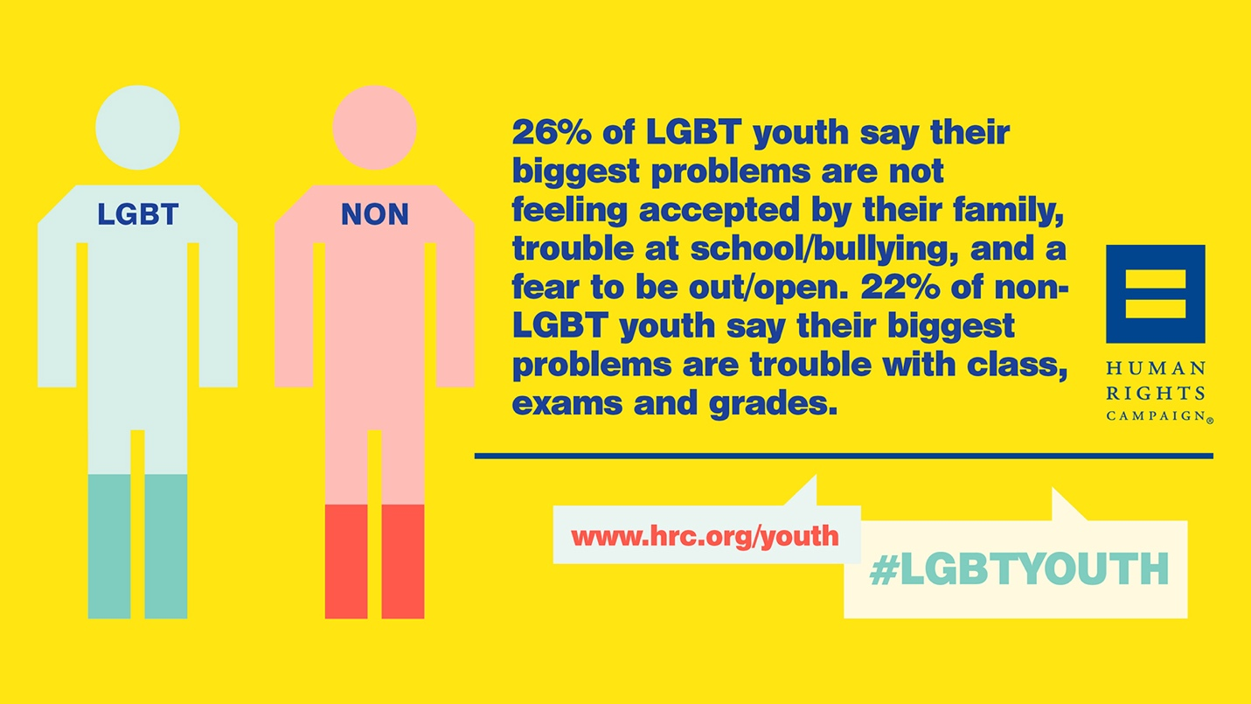
This graphic shows that students in the LGBTQ are more concerned about bullying at schools than exams and grades. No student should feel unsafe in their classroom. If students do not feel safe in their learning environment, they will not learn. Clearly, LGBTQ students do not feel safe in their environment. They cannot be concerned with exams and grades if they fear bullying or acceptance.

Appendix D: Mrs. Marijke Leibel presented in class on her dissertation on the LGBTQ community. In this presentation, she used a handout to share some information. There is a state map that highlights what states have laws protecting LGBTQ students. There is only a small number of states that have passed laws. This means that LGBTQ students can be discriminated against or harassed and there are no laws protecting the students.

References
Treuer, A. (2012). Everything You Wanted to Know About Indians but Were Afraid to Ask. St. Paul, MN: Minnesota Historical Society Press.
Spradlin, L.K. (2012). Diversity Matters. Belmont, CA: Wardsworth Cengage Learning.

