Unit Plan Overview: The objective of this unit is to get students thinking about their rights as listed in the Bill of Rights and how those rights are addressed today. Students will analyze current articles about those rights being questioned. I choose an article explaining both sides of gun control and an article that explains 10 court cases that questioned different amendments. It makes the Bill of Rights come alive as students can see it in action and how the Supreme Court upholds the Bill of Rights. I want students to deeply discuss their rights.

Readings/Images:
- Bill of Rights, Lexile: 1450. This reading is above the lexile range for 11 and 12th grade (1185-1385), but I believe it is needed because it is a historical document. Students must read and understand this document even though it is out of their range. I plan on having students paraphrase the document and also frontloading the document to make understanding it easier.
- “Ten Supreme Court Cases Every Teen Should Know” http://www.nytimes.com/learning/teachers/featured_articles/20080915monday.html, Lexile: 1160L. Although this document is below the Lexile level for the grade, I believe it has a lot of good information because it tells the background of the case and the ruling. Students can then deeply think about the ties between the ruling and the Bill of Rights. I will assign this document to the lower level readers of the class.
- “Supreme Court Landmarks” http://www.uscourts.gov/about-federal-courts/educational-resources/supreme-court-landmarks, Lexile: 1180. This document is very close to the range for the grade level. It is only 5 below. It is a court document overview so the students will have to read and understand some court language. It nicely describes the court cases and denotes if they impact students.
- 2 images in the anticipatory sets.

Lesson Plan Day #1 Before Reading
Grade Level: 11th or 12th
Subject: Government/Civics
50 Minute Lesson

Materials Needed: Copies of Bill of Rights, Projector

Standards:
9–12.4.3 Analyze the content and context of documents, events, and organizations that influenced and established the United States (e.g., Magna Carta; English common law; Petition of Right; English Bill of Rights; 1st and 2nd Continental Congresses; Common Sense; Declaration of Independence, American Revolution Articles of Confederation; Constitutional Convention; Federalist Papers, Anti- Federalist Papers; U.S. Constitution, Bill of Rights)

9–12.4.5 Analyze historical and contemporary examples of civil liberties and civil rights in the U.S. (e.g., incorporation of the Bill of Rights, amendments, key legislation, and landmark Supreme Court cases)

Objectives:
Students will understand the Bill of Rights and its impact on society through history.
Students will create the Bill of Rights in their own words.
Students will critically think about how the Bill of Rights is being questioned in today’s society.

Lesson Activities:
- Anticipatory Set: Show Image/Quote from George Washington on board. Have students write a paragraph reflection on what they believe the quote means and how they connect it to the United States today. (10 minutes)

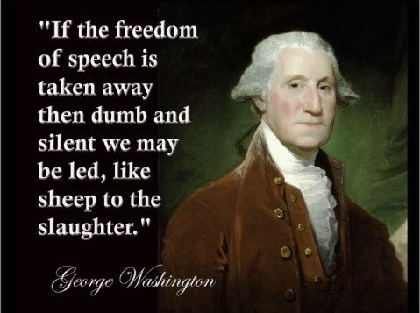
https://www.google.com/url?sa=i&rct=j&q=&esrc=s&source=images&cd=&cad=rja&uact=8&ved=0ahUKEwid9J7IpuzQAhVMziYKHcTKCgYQjRwIBw&url=https%3A%2F%2Fwww.pinterest.com%2Fexplore%2Ffreedom-of-speech%2F&psig=AFQjCNGtXdtCJSmQieGlgVCannfaOxe1Qg&ust=1481551229957678
- Ask a few students to share their answers. Connect the quote to the Bill of Rights. (5 minutes)
- PowerPoint refresher on the history of the Bill of Rights. (5 Minutes)
- Think Pair Share: Questions: Are any of these rights being questioned today? Have you heard of any recent controversy over these rights? Which ones and why do you think that is? Class discussion on First and Second Amendment. (10 minutes)
- Pair students by proximity. Individually students will read the Bill of Rights. Pairs will then rewrite the Amendments in their own words. (20 Minutes)

Assessment: Students will turn in the paraphrased Bill of Rights. This will ensure that students know the Bill of Rights well, so it creates a base of knowledge for deeper thinking of the Bill of Rights in action in the United States in the next lessons.

Reflection: Depending on the background knowledge of this lesson, it could go faster or slower. By junior and senior year I would think most students would know the Bill of Rights well, but I’m not sure. More or less frontloading may be needed. The purpose of this lesson is for students to have a strong understanding of the Bill of Rights so they can critically analyze future readings because they know their rights.

Lesson Plan Day #2 During Reading
Grade Level: 11th or 12th
Subject: Government/Civics
50 Minute Lesson

Materials Needed: copies of articles for every student, image of protestors, projector

Standards:
9–12.4.3 Analyze the content and context of documents, events, and organizations that influenced and established the United States (e.g., Magna Carta; English common law; Petition of Right; English Bill of Rights; 1st and 2nd Continental Congresses; Common Sense; Declaration of Independence, American Revolution Articles of Confederation; Constitutional Convention; Federalist Papers, Anti- Federalist Papers; U.S. Constitution, Bill of Rights)

9–12.4.5 Analyze historical and contemporary examples of civil liberties and civil rights in the U.S. (e.g., incorporation of the Bill of Rights, amendments, key legislation, and landmark Supreme Court cases)

Objectives:
Students will analyze photos and documents to discover how the Bill of Rights impacts society today.
Students will critically analyze court cases and connect the cases to the Bill of Rights.
Students will professionally discuss findings in larger groups.
Lesson Activities:
- Anticipatory Set: Reading a Visual Image: Project photo of gun law protestors on board in quadrants. Have students fold paper in quadrants and take notes on each quadrant. Class discussion on what amendments they see in action in the image (Freedom of speech and assembly all while fighting for the right to bear arms) (10 minute to analyze the visual, 10 minutes to discuss)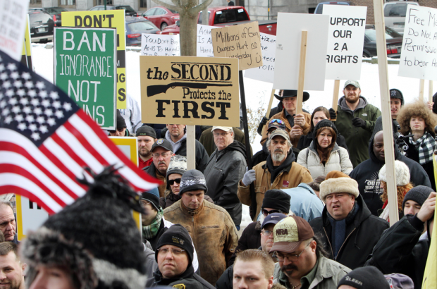

2)Students are assigned one of the two articles based on their reading level,“10 Supreme Court Cases Every Teen Should Know” or “Supreme Court Landmark.” Students will read the articles and annotate the text.
3) Everyone who read the article will come together as a larger group to discuss the article. The group will compare annotations and answer questions. The purpose of the discussion will be to have a broader conversation about the amendments and rights the article addresses. Students can have a copy of the Bill of Rights with them to refer to. Monitor both group discussions. Ask prompting questions and get all students involved. (20-30 minutes)
4) Whole class discussion on rights of students and any interesting court cases

Assessment: Students will turn in their annotations of the articles. I can then help students who may struggle with annotations and answer any questions they may have written down.

Reflection: If I could video/record one group to make sure everyone is participating, that would be an excellent option. It will be difficult to get all students involved in larger groups, but I want every student to add something to the discussion. Monitoring might be difficult in the group. I foresee that being a concern.

Lesson Plan Day #3 After Reading
Grade Level: 11th or 12th
Subject: Government/Civics
50 Minute Lesson

Materials Needed: copies of articles for every student

Standards:
9–12.4.3 Analyze the content and context of documents, events, and organizations that influenced and established the United States (e.g., Magna Carta; English common law; Petition of Right; English Bill of Rights; 1st and 2nd Continental Congresses; Common Sense; Declaration of Independence, American Revolution Articles of Confederation; Constitutional Convention; Federalist Papers, Anti- Federalist Papers; U.S. Constitution, Bill of Rights)

9–12.4.5 Analyze historical and contemporary examples of civil liberties and civil rights in the U.S. (e.g., incorporation of the Bill of Rights, amendments, key legislation, and landmark Supreme Court cases)

Objectives:
Students will critically analyze a document and demonstrate understanding of different perspectives.
Students will connect the Bill of Rights and contemporary court cases.
Students will understand the importance of the Bill of Rights.
Lesson Activities:
- Review of some of the court cases read in yesterday’s lessons and what amendments they covered (5 minutes)
- Both articles covered one common court case Hazelwood v. Kuhlmeier. Today we are going to read more into that case. Both groups know what verdict came from the case, but I want you guys to put yourself into the roles of the court to see both sides of the argument. In the article,you read yesterday, please go back and review the case.
- Pair students by proximity, Handout short “Facts” excerpt from http://www.uscourts.gov/educational-resources/educational-activities/facts-and-case-summary-hazelwood-v-kuhlmeier. Students will read as pairs. Each student in the pair will take a role either School District or Students. After reading the excerpt they must write a paragraph argument on why they think their side is correct. Students will use information from the excerpt to back up their claim.
- Whole class discussion on: Why did the courts rule in that way? How was the Bill of Rights upheld by the Supreme Court? Do You think the decision was correct? Would this happen in a school in North Dakota?

Assessment: Students will research a supreme court case on their own from the documents they were given the day before. Students must write a half page reflection on how that case upheld the Bill of Rights and if it was in their opinion the best verdict.

Reflection: I would try to do a debate over the court case if I was well educated on the case. I hope to get great class discussion from this court case because it directly impacted students like themselves. This whole unit, I hope to have good discussion. This is not at topic that I want to make only pencil and paper. I want students criticaly thinking about and sharing how the Bill of Rights affects them personally. It is a important to see their rights, not only on paper, but in action.

